CSA1413
COMPILER DESIGN
Name: Haresh Kumar N L
Reg No: 192425009
Implementation of Shift-Reduce Parser

Aim:
To write a C program to implement a Shift-Reduce Parser for the given grammar and display each SHIFT, REDUCE, and ACCEPT operation performed while parsing the input string.

Algorithm:
- Start the program.
- Include the required header files and initialize the parsing stack.
- Read the input string from the user.
- Check the input string character by character.
- Perform the SHIFT operation to push id or + onto the stack.
- Perform REDUCE operations using the grammar productions:
T → id
E → T
E → E + T
- Display each SHIFT and REDUCE operation performed.
- If the input is completely processed and the stack contains only E, perform the ACCEPT operation.
- Otherwise, display REJECT for an invalid string.
- Stop the program.

Pseudocode:
BEGIN
Initialize stack
Set top = -1
Set input position = 0
Read input string
WHILE TRUE DO
IF input is not empty THEN
IF current input is "id" THEN
PUSH "id" onto stack
Move input position forward
DISPLAY SHIFT
ELSE IF current input is "+" THEN
PUSH "+" onto stack
Move input position forward
DISPLAY SHIFT
ELSE
DISPLAY REJECT
EXIT
END IF
END IF
IF top element is "id" THEN
REDUCE T -> id
END IF
IF stack contains E + T THEN
REDUCE E -> E + T
ELSE IF top element is T THEN
REDUCE E -> T
END IF
IF input is empty AND stack contains only E THEN
DISPLAY ACCEPT
BREAK
END IF
IF input is empty THEN
DISPLAY REJECT
BREAK
END IF
END WHILE
END

Code:
#include <stdio.h>
#include <string.h>
int main()
{
char input[100];
char stack[100][10];
int top = -1;
int i = 0;
printf("Enter input string: ");
scanf("%99s", input);
printf("\nSTACK\t\tINPUT\t\tACTION\n");
while (1)
{
if (input[i] != '\0')
{
if (input[i] == 'i' && input[i + 1] == 'd')
{
strcpy(stack[++top], "id");
i += 2;
}
else if (input[i] == '+')
{
strcpy(stack[++top], "+");
i++;
}
else
{
printf("REJECT\t\t%s\t\tInvalid String\n",
input + i);
return 0;
}
stack[top + 1][0] = '\0';
printf("%s\t\t%s\t\tSHIFT\n",
stack[0], input + i);
}
if (top >= 0 && strcmp(stack[top], "id") == 0)
{
strcpy(stack[top], "T");
printf("T\t\t%s\t\tREDUCE: T -> id\n",
input[i] ? input + i : "$");
}
if (top >= 2 &&
strcmp(stack[top - 2], "E") == 0 &&
strcmp(stack[top - 1], "+") == 0 &&
strcmp(stack[top], "T") == 0)
{
top = top - 2;
strcpy(stack[top], "E");
printf("E\t\t%s\t\tREDUCE: E -> E + T\n",
input[i] ? input + i : "$");
}
else if (top >= 0 && strcmp(stack[top], "T") == 0)
{
strcpy(stack[top], "E");
printf("E\t\t%s\t\tREDUCE: E -> T\n",
input[i] ? input + i : "$");
}
if (input[i] == '\0' &&
top == 0 &&
strcmp(stack[top], "E") == 0)
{
printf("E\t\t$\t\tACCEPT\n");
break;
}
if (input[i] == '\0')
{
printf("REJECT\t\t$\t\tInvalid String\n");
break;
}
}
return 0;
}

Input:
id + id

Output:
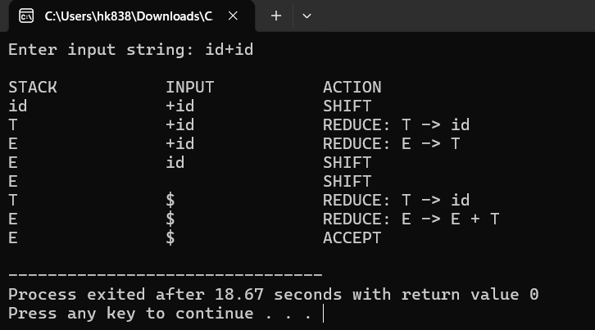
Result:
Thus, the C program to implement a Shift-Reduce Parser and perform SHIFT, REDUCE, and ACCEPT operations for the given grammar was executed successfully.

